**Adam Gincel and Mark Watson**

**Group 1**

**Experiment 5: First Order Systems**

**April 28th, 2015**

**Introduction:** In this experiment we learned about first order systems, which are systems that obey first order differential equations. We applied our knowledge to AC and DC circuits as we calculated various values based on a resistor and a capacitor. Between the two types of circuits, we found high pass phase, high pass amplitude, low pass phase, low pass amplitude, cutoff frequency, frequency constant, and time constant. This experiment reaffirmed our knowledge regarding measuring resistances theoretically and practically, setting up circuits, and measuring data in Capstone.

**Equations Used:**

**Data:** See attached Excel Sheets and Graphs.

**Conclusion:** Our first order systems, for both the potential differences of resistances and capacitors as well as the first order system of voltages across the resistors that we graphed and tabled followed the theoretical values. With the proper setup of circuits and correct measurements of resistance and capacitance we found the theoretical and experimental time constant to be of <5% error. We also found the cutoff frequency and had a percent error of <10% for that experiment. Either way our calculations matched our expected results, confirming our experiment and ensuring our understanding of circuits and such. Potential error did exist in our experiment, mainly due to the imperfect nature of resistors and capacitors in a lab environment, as well as the discrete measurements made by our interface. Understanding this, we working with error in mind and still managed to find various values and reached a sufficient data conclusion, and have gained more experience in working with these physical systems.

*Week 1 Resistor measurement:*

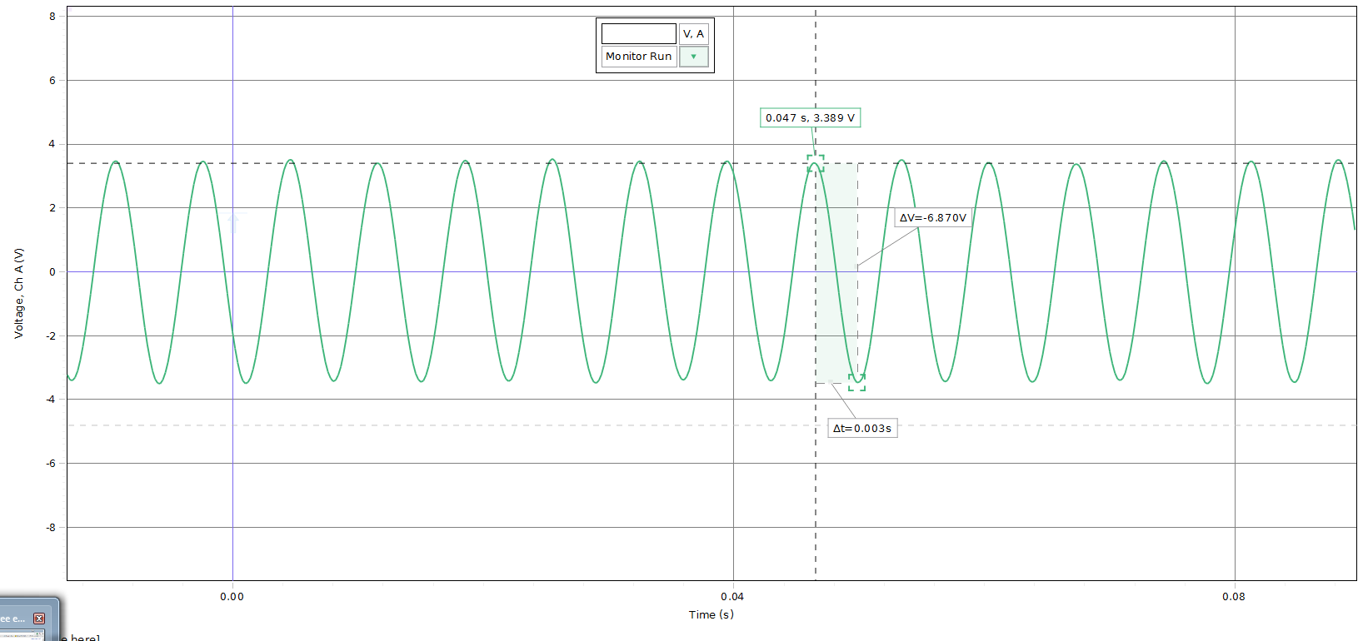

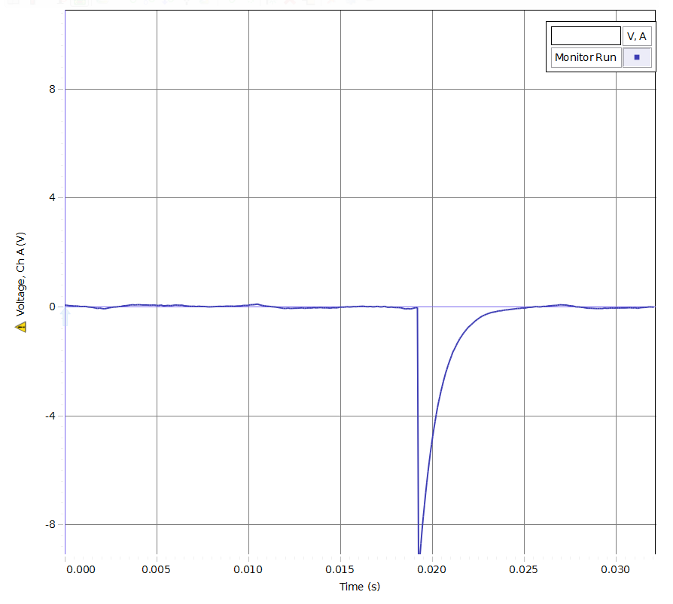

*Week 2 measurement:*